BRETHERTON ENDOWED CE
PRIMARY SCHOOL
South Road
Bretherton
Lancashire
PR26 9AH
Tel/Fax (01772) 600431
Email: head@bretherton.lancs.sch.uk

Walking in the footsteps of Jesus with our Christian family, we learn, grow, achieve and flourish together in God’s love.

Bretherton Endowed CE Primary School Loan Agreement for the loan of technology.

It has been agreed that your child will be allocated the use of technology whilst in national lockdown and schools are closed to the majority of children in order to aid their remotre learning at home.

In order to allow the technology to be taken off-site, we need to establish terms of agreement on its appropriate use and upkeep.

You are asked to sign this agreement to show that you agree to uphold the rules set by the school for the use of this equipment.

Parent/Carer’s Agreement for loan of technology for use by their child
- I will ensure that the internet facilities on this equipment will only be used to access child-friendly educational programs.
- Your child will only access the systems and device with their own login and password, which they will keep secret.
- They will use the iPad for school work and homework
- The messages they send will be polite and responsible.
- They will not give any of their personal information out to anyone online
- You or your child will report any unpleasant material or messages sent to me. These reports will be confidential but may be used to protect other students and themselves
- Your child understand that use of the technology is subject to the schools Acceptable Use of ICT Policy
- I understand that I cannot use this equipment for personal use and that only your child is allowed to use it with support [as appropriate] from their Parents/Carers.
- I will accept full responsibility for any malicious damage incurred to this equipment or the applications while the equipment is in my care.
- I will support my child’s use of Google Classroom as the platform for their remote learning.
- I understand that I will return the technology on return to school for use within school and keep us updated if any updates are required.

Schools Agreement for loan of technology
- We will support parents and children to access the technology, as much as possible while learning remotely.
- We will offer regular support vis the Google Classroom platform for online learning.
- We will make the technology available as much as possible for families who need support in remote learning.

Signed by parent………………………………………………….

Date……………………………………………………………….

Signed by school …………………………………………………

Date……………………………………………………………….

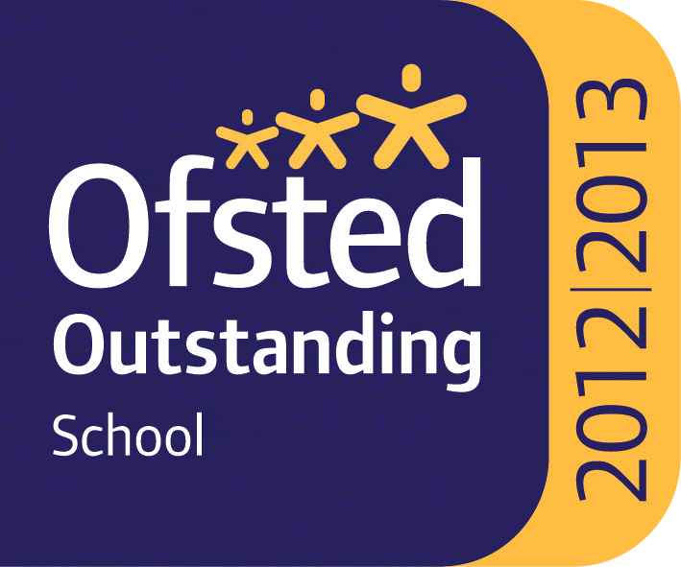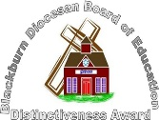

Headteacher : Mrs Alison Moxham Chair of Governors : Mr T. G. Wilson www.brethertonschool.org.uk

