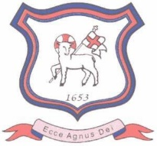

January 2023

Dear Parents / Carers

I’m writing to inform you that Class 2 will be taking part in the Key Stage 1 Young Leaders Award this term. We’re excited to be involved in this programme. For more information visit www.abyyt.com.

The Young Leaders Award at Key Stage 1 explores four key characteristics: kindness, perseverance, teamwork and action. It also gives pupils opportunities to take part in practical activities and challenges to help those around them and their local community.

During this term pupils will take part in a ‘Random Acts of Kindness’ challenge which asks them to complete simple challenges in school and at home to show kindness to others. They will each receive a grid of challenges. We ask that you support your child to complete these home challenges and to ensure that you provide any relevant supervision.

There may be opportunities for parents and family members to get involved in a community action project that will take place later in the term, and we will be in touch with more details nearer the time

At the end of the award each child will receive a certificate and we will host an awards celebration. More details about this will follow.

Mrs Moxham will be teaching Class 2 one afternoon a week when swimming ends later this month and they will be covering these sessions on this afternoon.

Thank you in anticipation for your support with this exciting project.

Yours sincerely

Mrs A Di Franco , Class Teacher

