
BRETHERTON ENDOWED CE
PRIMARY SCHOOL
South Road
Bretherton
Lancashire
PR26 9AH
Tel/Fax (01772) 600431
Email: head@bretherton.lancs.sch.uk

Walking in the footsteps of Jesus with our Christian family, we learn, grow, achieve and flourish together in God’s love.

Impact report for Pupil Premium spending 2020/2021

Number of children included within this report : 9
Key focus

In school barriers
- Social and emotional intelligence: Pupils building self confidence and building self esteem as learners.
- Pupils are able to talk about their emotions and have high aspirations to improve, support required to maintain self esteem and self worth.
- Key skills in Reading, Writing & Maths for KS2 children eligible for PP hold back accelerated progress needed to close the attainment gap.
- Reading and phonics support and additional sessions for ks1. Reading accuracy and comprehension support for ks2. Vocabulary in all KS’s
- Staff report a high proportion of pupils eligible for PP need to develop resilience in learning to combat issues such as concentration skills, memory or organisational skills.

External barriers

- All PPG pupils monitored attendance monthly and pro active action taken and recorded
- Sleep is a concern in a number of PPG pupils – relax kids,peer massage,anxiety reduction kit
- Mediation between separated parents is causing concern for children – stability of routines needed. Concerns regarding finances for families separated
- To promote and enhance cultural capital through the arts and outdoor learning opportunities

Strengths of provision:
- CPD of staff in relation to supporting PPG children and wellbeing
- Quality first, strong teaching in all classes
- Relational experiences between children and staff
- Balance of persoanlised support for parents financially and overcoming barriers in academic learning
- Provision mapped
- Pupil progress meetings
- Communication and collaboration with parents and community
- Community support
- Use of Confident Me and peer massage (except during Covid)
- Staff CPD on Emotion Coaching in school and the Hub
- Resources ‘Hidden Chimp’

Impact on results:

Attainment for: 2020 – April 2021 | Pupils eligible for PP (your school)
% achieving expected standard or above in reading, writing and maths | 77% (2)
% achieving expected standard or above in reading | 88.88% (1)
% achieving expected standard or above in writing | 66.66% (3)
% achieving expected standard or above in maths | 77% (2)

Each child is 11%

Covid -19 has been a challenge for all families but in particular PPG families. Support from local parish council has provided food parcels and additional food voucjers outside the local council and school led voucher system.

Inpact on whole child/family:

- Provision of support for food within Covid -19 lockdown
- Pastoral TA training and provision
- Sports opportunities and lunch time sports TA
- After school clubs (offered once Covid allowed)
- Parent workshop booked for parents
- Use of early help re- separation
- School Nurse involvement
- ELSA pastoral support/conference/CPD
- Forest school TA time out of school to complete course
- Forest school area resources

Children | After school clubs  Accessed | Financial support for trips/uniform | 1 to 1/ small group pastoral work | Enrichment drama/sport/farm | Pastoral TA support | Accessing lunch time games
KS1/EYFS (2) | 0 | 1 | 0 | 2 | 2 | 2
KS2 ( 7) | 5 | 6 | 2 | 7 | 7 | 6
PLAC (3) | 2 | 0 | 2 | 3 | 3 | 2

Areas for development/ unmet needs for the next strategy document:

- Writing
- Post LAC termly review meetings as with Covid, not able to be completed
- Individual provision plan for FSM children with targets.
- PPG and SEND children reporting to be completed by different members of staff to ensure champion of each.
- Review of cultural capital provision of whole school and in particular for PPG children
- To review post covid, to ensure all parties who are eligible have applied.
- Structured out of hours club, including forest school

May 2021

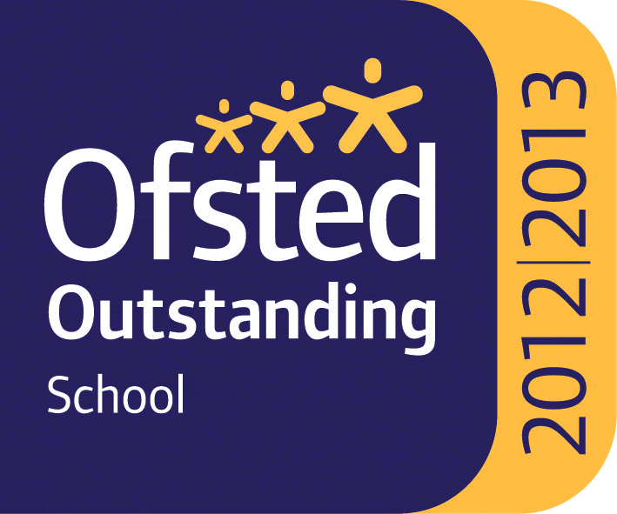

Headteacher : Mrs Alison Moxham Chair of Governors : Mr T. G. Wilson www.brethertonschool.org.uk

