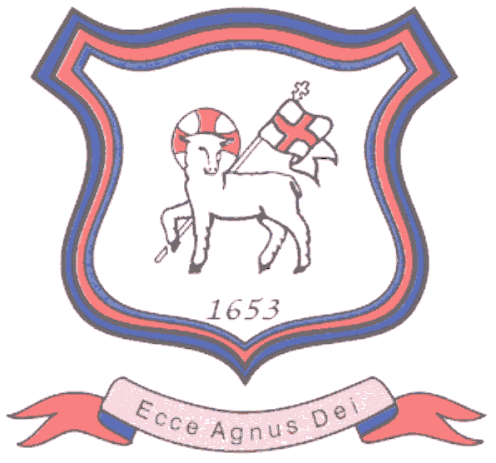
BRETHERTON ENDOWED CE
PRIMARY SCHOOL
South Road
Bretherton
Lancashire
PR26 9AH
Tel/Fax (01772) 600431
Email: head@bretherton.lancs.sch.uk

“Learning together, growing together, achieving together, caring together
within our Christian family”
Dear Parents,

At the start of the year, we welcomed you into school for our ‘Meet the Teacher’ to support your child in settling into their new class. So next half term, we will be holding our first Parents’ Evenings of this school year to give you the opportunity to look at your child’s work and discuss their progress with their teacher. The times and dates are as follows:

- Tuesday 14th November 2017 from 5.00- 7.00 pm
- Thursday 16th November 2017 from 3.30 – 5.30 pm

On arrival at school please make your way to the Hall where your child’s work will be available for you to look at. You will then be invited by a member of staff to your appointment in your child’s classroom - please wait in the hall until a member of staff approaches you. Each appointment will last five minutes. If you feel there are still matters you wish to discuss then please contact school to arrange a further appointment with your child’s class teacher. I will be available throughout both evenings if you would like to speak to me. Could you please indicate your preferred time below and return the slip to school by Wednesday 8th November 2017. An appointment time will then be sent home.

Thank you for your continued support.

Mrs Alison Moxham
Headteacher
-----------------------------------------------------------------------------------------------------------------

PARENTS’ EVENING REPLY SLIP

Child(ren)s Name : _______________________________________ Class : ____________

TUESDAY 14th NOVEMBER THURSDAY 16th NOVEMBER

5.00 p.m. - 5.30 p.m. ________ 3.30 p.m. - 4.00 p.m. ________

5.30 p.m. - 6.00 p.m. ________ 4.00 p.m. - 4.30 p.m. ________

6.00 p.m. – 6.30 p.m. ________ 4.30 p.m. - 5.00 p.m. ________

6.30 p.m. – 7.00 p.m. ________ 5.00 p.m. – 5.30 p.m. ________

