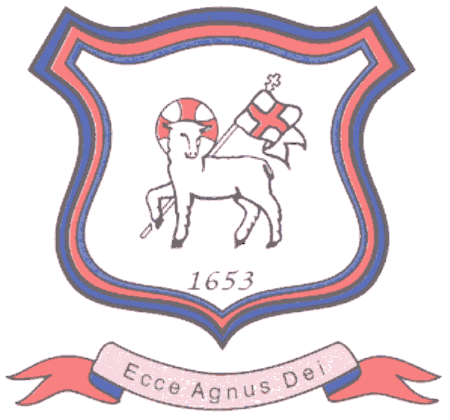
BRETHERTON ENDOWED CE
PRIMARY SCHOOL
South Road
Bretherton
Lancashire
PR26 9AH
Tel/Fax (01772) 600431
Email: head@bretherton.lancs.sch.uk

“Learning together, growing together, achieving together, caring together
within our Christian family”

Staffing changes in Class 2 and Class 3:

Class 2:
I am delighted to confirm that Mrs Jayne Clarke, our new Deputy Head Teacher, will start at Bretherton after Christmas. As well as teaching in Class 2 for 4 days, Jayne will be leading the teaching of English, Science and Music, along with singing in school. She will be coming into school a couple of times this half term to get to know the children and to ensure a smooth transition into next year. Miss Hymers will continue to do 1.5 days in Class 2, working in partnership with Mrs Clarke.

A date for your diary: Mrs Clarke will hold a "Meet the Teacher" on Monday 8th January 3.15 - 4pm. You are welcome to come along and meet her, to discuss your child or ask any questions you may have.

Class 3:
Mrs Helen Rowley, who has been on maternity leave, will be returning to work in January. She will be working 3 mornings a week, in partnership with Mrs Allchurch, who will continue to work 4 full days each week. This arrangement will allow us to hold regular focussed breakout groups in English & Math for year 4 and 5 and is a great opportunity for Year 4 and 5 to receive more personalised learning for the remainder of this school year, when I will review it. In addition, Miss Hymers will teach Class 3 on a Friday.

Sadly, this means Miss Motherwell will be leaving us at Christmas. We will be really sad to see her go, as she has had a really positive impact in Class 3, and in Science & PE across the whole school. I would like to thanks her for her commitment and passion for teaching and as she resumes supply teaching, we hope we may be able to call on her again in the future.

There are no changes planned for Class 1 & Class 4.

Class 1 Mrs Lesley Williams
Mrs Karen Hudson
Mrs Margaret Barratt
Mrs Debbie Brindle
Mrs Vanessa Glew

Class 2 Mrs Jayne Clarke ( 4 days)
Miss Lesley Hymers ( 1.5 days)
Mrs Jackie Vincent
Mrs Alison Williams

Class 3 Mrs Sarah Allchurch ( 4 days)
Miss Lesley Hymers ( 1 day)
Mrs Helen Rowley ( 3 mornings)
Mrs Judith Buffey
Mrs Vanessa Glew

Class 4 Mrs Nicola Smith
Mrs Vanessa Glew

Please do let me know if you have any queries - my door is always open.

In the meantime, I hope you will join me in welcoming Mrs Clarke to our Bretherton family, and I know those of you who know Mrs Rowley, will be delighted that she is returning to us.

Thank you for your continued support,

Alison Moxham
Head Teacher

