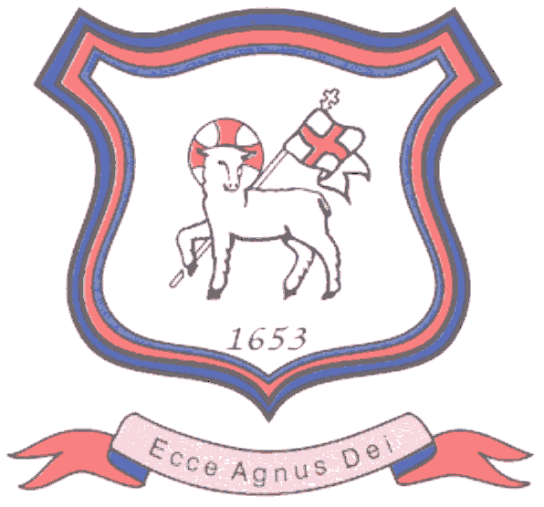
BRETHERTON ENDOWED CE
PRIMARY SCHOOL
South Road
Bretherton
Lancashire
PR26 9AH
Tel/Fax (01772) 600431
Email: head@bretherton.lancs.sch.uk

“Learning together, growing together, achieving together, caring together
within our Christian family”

Dear Parents

There is much national concern around children and their physical inactivity, and the rising levels of childhood obesity. Across the UK 35% of children in their final year of Primary are categorised as obese or overweight, the World Health Organisation have described this as one of the most serious global public health challenges of the 21st Century.

As you will know, Bretherton children are very active. Following the successful trial during our Health week we have chosen to implement the Daily Mile to increase daily activity in school and to gain the physical, health, social and emotional well-being aspects of being more active.



Without spending time to change into kit, every child will go out with their classmates into the fresh air (in nearly all weathers) to run, jog or walk in the safety of the school grounds. It will take 15 minutes from desk, back to desk. Everyone has fun taking part- it is not P.E. and it is not competitive - we will be building relationships, confidence and resilience.

The benefits can be summed up in the Five F’s : Fitness, Fresh Air, Friends, Fun and Focus.
In order to support the Daily Mile, we would appreciate it if your child could keep a pair of trainers in school. Your child’s safety is our primary concern and therefore suitable footwear is needed, PE pumps will not be suitable for the outdoor run, nor are many school shoes. There is no need for high end or named trainers, many of the major supermarkets stock suitable trainers for relatively low prices. These trainers will be kept in the children’s school PE bags and must be clearly named. We would appreciate them being in school for the week commencing 22nd January 2018.

We would also welcome your support at home, by both encouraging their confidence in running, and moving outside with them out of school hours. Parents say that The Daily Mile helps children to eat and sleep better, and that often they become young ambassadors for whole family fitness!
We look forward to the start of this initiative.

Kind Regards

Mrs Glew

Mrs V Glew
Teaching Assistant

