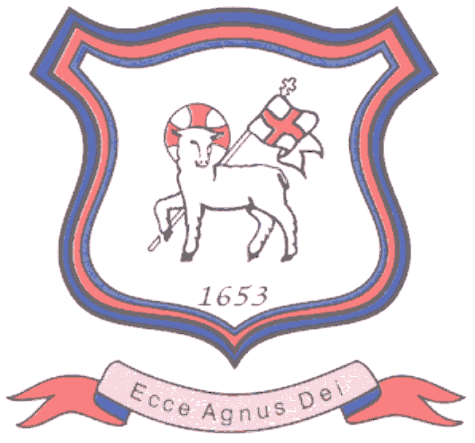
BRETHERTON ENDOWED CE
PRIMARY SCHOOL
South Road
Bretherton
Lancashire
PR26 9AH
Tel/Fax (01772) 600431
Email: head@bretherton.lancs.sch.uk

Walking in the footsteps of Jesus with our Christian family, we learn, grow, achieve and flourish together in God’s love.

Dear Parents/Guardian

We are writing in light of changes made to national policies on self-isolation and to provide information on how COVID-19 will be managed in the school this term. This letter has been written from a template provided from Lancashire County Council.

CHANGES TO NATIONAL SELF-ISOLATION GUIDANCE

From 16 August, the Government has said that people aged under 18 years and 6 months or who are fully vaccinated will no longer be legally required to isolate if they are a close contact of someone with COVID-19. Instead, such people will be advised (but not legally required) to get a PCR test unless they have had a positive PCR test in the previous 90 days.
Regardless of age or vaccination status, anyone who develops any of the three main COVID-19 symptoms (see below) must get a PCR test as soon as possible and isolate until the result is available. People who get a positive PCR test must continue to isolate as usual.

Some likely scenarios are described below along with our advice:

What should I do if my child develops COVID-19 symptoms?
The main symptoms of COVID-19 are:
- new continuous cough and/or
- fever (temperature of 37.8°C or higher)
- loss of or change in, normal sense of taste or smell (anosmia)

If your child develops any of these symptoms, you must arrange for them to have a PCR test as soon as possible. A PCR test can be arranged via the NHS UK (www.nhs.uk) website or by contacting NHS 119 via telephone if you do not have internet access.
Your child should self-isolate immediately and they should not attend school.
Please contact the school by phone to inform us your child has COVID-19 symptoms and you are awaiting a COVID-19 test.

What should I do if my child has COVID-19 confirmed by PCR test?
Anyone with COVID-19 confirmed by PCR test should self-isolate until the latest of:
- 10 days after the onset of their symptoms, or
- 10 days after their test day if they are asymptomatic

Self-isolation means your child should not go to school, attend any out of school activities or visit a friend’s house. They should not visit any public places, use public transport or go out to exercise. You should not have vistors into the home except for those providing essential care.

Please contact the school by phone and inform us your child has COVID-19 confirmed by PCR test. It is really important you let us know if your child has confirmed COVID-19 so we can monitor the number of children with COVID-19 across the school.

What should I do if my child is a contact of someone with COVID-19 confirmed by PCR test?
If your child is aged under 18 years and 6 months and does not have any symptoms of COVID-19 (high temperature, new continuous cough, loss of or change in, normal sense of taste or smell) they do not have to self-isolate as a contact of COVID-19.
They are advised to have a PCR test unless they have had a positive PCR test in the last 90 days.
Children aged 5 and under are not advised to take a PCR test unless the confirmed case is someone in their own household.

What should I do if my child has a positive result on a lateral flow device test?
If your child has a positive result on a lateral flow device test, they should self-isolate immediately and you should arrange a PCR test as soon as possible.
Other members of the household do not need to self-isolate whilst you await the PCR test result if they do not have symptoms and are aged under 18 years and 6 months or are fully vaccinated.

What should I do if my child is unwell with signs of an infection but does not have symptoms of COVID-19
Your child should be excluded from school if they are unwell. If concerned you should seek advice from your GP or Pharmacist, they will be able to advise you how long your child should stay off school. Otherwise we would recommend exclusion for 48 hours or until the child is symptom free, whichever is longer. We are not currently advising that preschool children get a PCR test if they do not have the three main symptoms of COVID-19.

Nursery and primary school pupils are not asked to test at this time

ACCESSING COVID-19 testing in Lancashire
Symptomatic testing and testing for close contacts
PCR tests can be booked at any of the DHSC run sites that operate Monday – Sunday 8am – 8pm on the gov.uk website https://www.gov.uk/get-coronavirus-test

PCR tests for home delivery can also be ordered by calling 119. We do have a limited number of home testing PCR tests at school.

Yours sincerely

Mrs A Moxham

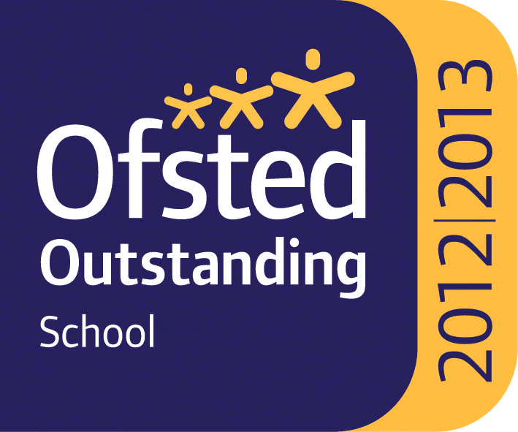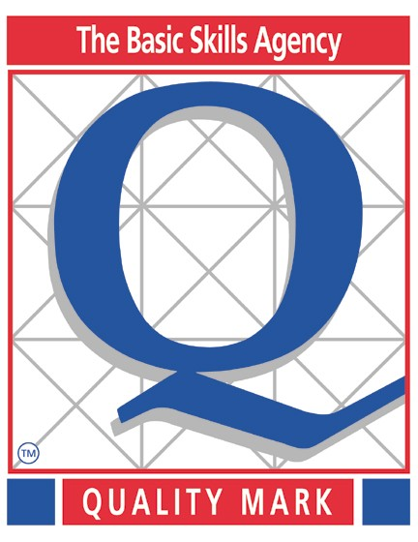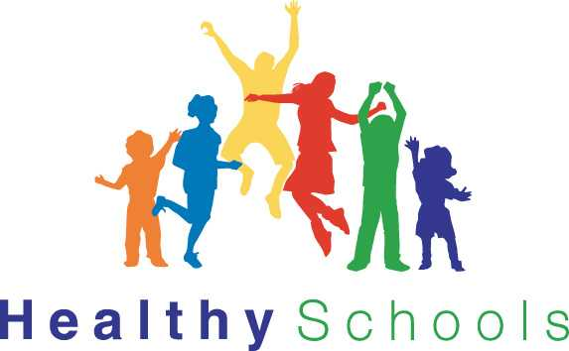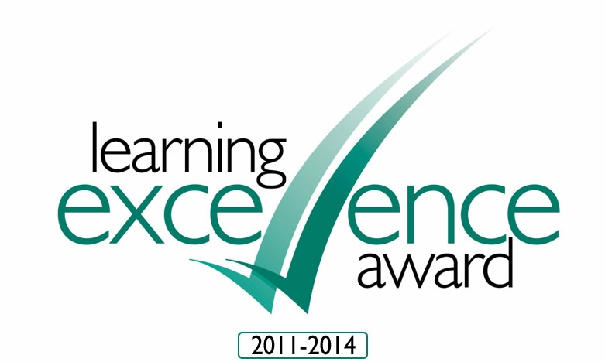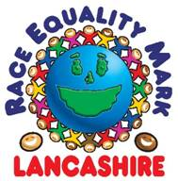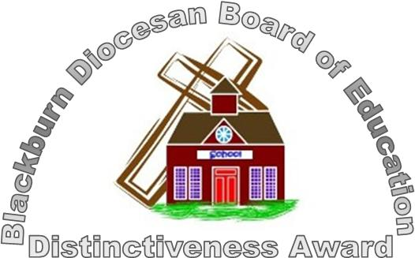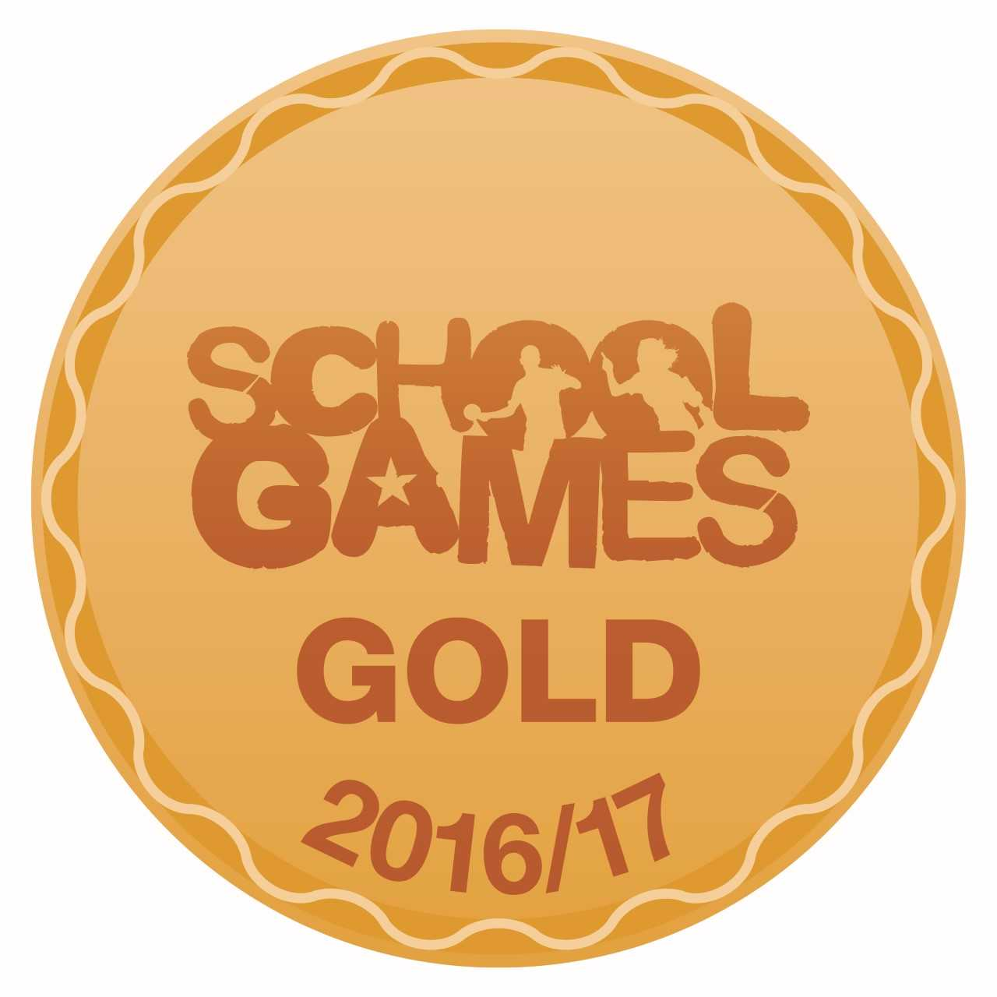

Headteacher : Mrs Alison Moxham Chair of Governors : Mr T. G. Wilson www.brethertonschool.org.uk

