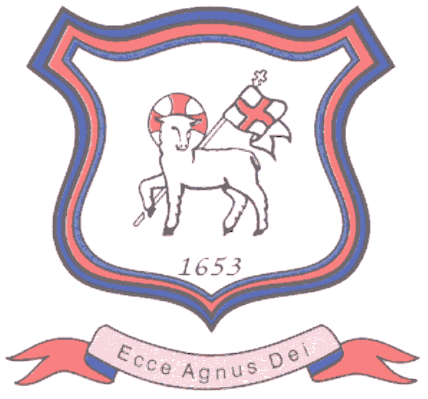
BRETHERTON ENDOWED CE
PRIMARY SCHOOL
South Road
Bretherton
Lancashire
PR26 9AH
Tel/Fax (01772) 600431
Email: head@bretherton.lancs.sch.uk

“Learning together, growing together, achieving together, caring together
within our Christian family”

The Ark Before and After School Provision

Dear Parents,

I have been advised by Mrs Angela Williams that she will no longer be operating ‘The Ark’ provision in the future and has given notice of intention to leave at the end of July 2018.

This news is a surprise to school as I am sure that it is to you but I am writing in the hope that I can minimise any concerns you may face in relation to wrap around provision for children at Bretherton. We are grateful that Mrs Williams has provided us with advanced notice and would like to thank her for her commitment and service to the children and families at Bretherton Endowed. I am certain you will join us in wishing her all the best for the future.

It is important that Bretherton school can offer you a well-run and effective before and after school provision which is of the highest standard and although it is early days, we would like to reassure you that we will be looking to ensure our school has a before and after school club available to use.

As you can appreciate there are some details that will take some time to determine, however, we will keep you informed as decisions are made.

If you have any questions, please contact me on 01772 600431 when school is back or email head@bretherton.lancs.sch.uk if you have any concerns that need addressing sooner.

Kind regards,

Alison Moxham

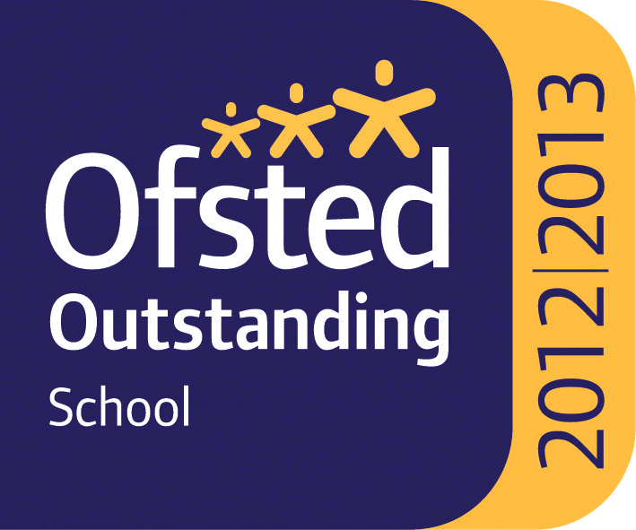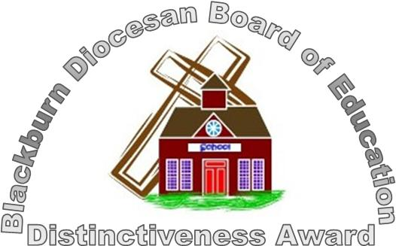

Headteacher : Mrs Alison Moxham Chair of Governors : Mr T. G. Wilson www.brethertonschool.org.uk

