
BRETHERTON ENDOWED CE
PRIMARY SCHOOL
South Road
Bretherton
Lancashire
PR26 9AH
Tel/Fax (01772) 600431
Email: head@bretherton.lancs.sch.uk

“Learning together, growing together, achieving together, caring together
within our Christian family”
Dear Parents,

We are running a Sponsored Readathon and we’d love your child to join in. We are hoping to raise some money to fund new library books for your child to enjoy in school. The more money we raise, the more books we can purchase. It’s been proven that children who read for pleasure are more likely to be successful and happy throughout their lives.

Pupils can choose whatever they want to read - from comics to classics and audio books to blogs - they are not being assessed, it’s all about reading for fun. And, they are motivated to read because the money they raise in sponsorship helps to provide new books for them in school.

All you have to do is:

- Take a look at what they plan to read, or help them complete their list of books to read or decide on a total number of pages they can read over a one week period. For younger children, maybe five short books over the week and for older children, maybe ten or more pages a night. It depends on the ability of your child but every little bit is important and we are encouraging children to challenge themselves. Remember they can read whatever they want: books, e-books, poetry, comics – anything goes! Sharing books is fine too (in fact recommended!).

- Help your child find sponsors among family and friends. Ask family and friends to sponsor per book, per page or a total amount for completing the challenge.

- Support your child as they complete their reading challenge over the week beginning 2nd July until 8th July. Complete the form we will send out on Friday that you can sign to show the number of pages/books read.

- Collect the sponsorship money and send it into school by 16th July.

Please support your child’s sponsored read as much as you can. They’ll be helping raise money for some new books and children will be consulted on the books we choose. Remember it is for fun and our aim is to encourage children to read for pleasure.

We hope you can support school in the Readathon.

Thank you

Mrs Clarke
Literacy subject leader

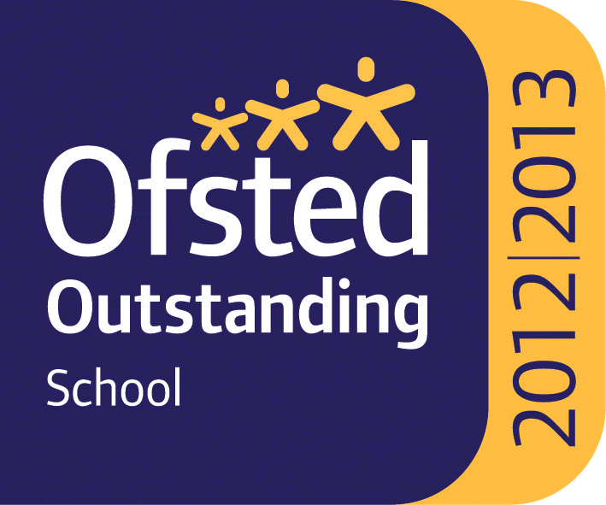

Headteacher : Mrs Alison Moxham Chair of Governors : Mr T. G. Wilson www.brethertonschool.org.uk

