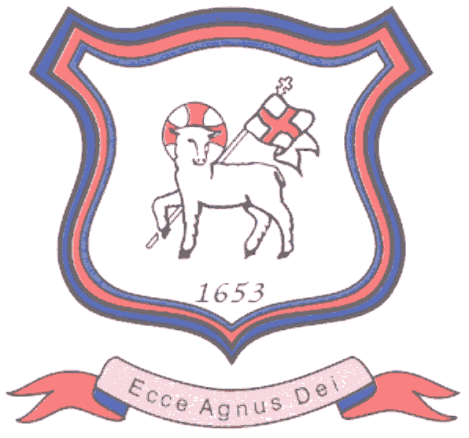
BRETHERTON ENDOWED CE
PRIMARY SCHOOL
South Road
Bretherton
Lancashire
PR26 9AH
Tel/Fax (01772) 600431
Email: head@bretherton.lancs.sch.uk

“Learning together, growing together, achieving together, caring together
within our Christian family”

Handwriting as a focus at Bretherton in 2018 2019

Where handwriting is mentioned in the National Curriculum, the major aim is that children produce neat, legible handwriting. What this doesn’t allow for is the other factors that are supported by children learning to write fluently and automatically.

At Bretherton we look for neat and thoughtful presentation of work but we also appreciate the positive impact handwriting can have on the craft of writing and of learning in general. We are interested in the brain, how it works and how it can support learning. We appreciate that handwriting is not merely a motor skill but a significant element of literacy on it’s own. We know that automatic handwriting can free up the brain to think about what is actually being written and that the physical movement of the hand is actually part of the thinking process.

For many children, handwriting continues to be a challenge that can stay with them through to High School which highlights the importance of getting the teaching of handwriting right at an early stage and developing it continuously through their education. There is a future challenge for the place of handwriting within education with the rise in computers and digital assisted composition and infact Finland has abandoned handwriting in favour of teaching touch typing in schools. Whilst there are some positive impacts of this, there is an equally powerful argument that handwriting really does matter and can be outlined in the following ways:

- Handwriting and memory

There have been many educational studies to evidence the link between fine motor skills and achievement later in school so when children are more adept at fine motor writing skills early in school, they were seen to have higher achievements in reading and maths in later years.
Other studies have shown that the body’s movements in writing links to motor activity in human cognative processing.In layman terms, posture, setting and the fact that in writing the body and mind work together to create a set of symbols to match a mental image. The brain has to work harder in doing this than chosing a letter on a keyboard and so this may account for the longer term effect on understanding and memory in learning that writing has.

- Handwriting and composition

There has been substantial research that has shown that automatic handwriting may have a significant effect on children’s composing. Handwriting is not just about training the hand but training the hand and mind to work together, automatically and without effort. Exploring the role of working memory also supports the teaching of handwriting as it is believed that if a child has to devote large amounts of working memory to the control of lower level processes such as handwriting, they may have little left for higher level processes. So making handwriting automatic frees up the brain to work on what is actually being written.

Handwriting, research has found, does not become automatic until around the age of 10 and even then continues to require cognative attention which further emphasises the need to regular, consistent teaching of handwriting in schools. Not just practice but teacher led focus on skills being taught.

There is also some emerging research that handwriting is critical not only to the creation of well structures and creative texts and impact not just on fluency but also on the quality of writing.

Yes handwriting has been clearly seen as supporting the teaching of spellings, however if handwriting can be a precursor to improved composition, we feel it should have a greater weight in our English curriculum.

Obviously there will be some children and some occasions when handwriting will be a struggle and we will support these situations as we support all our unique children. However, we feel that an increased focus on the explicit teaching of handwriting through all year groups in a consistent way will lead to increased progress overall.

In short:

Handwriting is not simply a motor skill but a significant element of literacy in it’s own right.

Fluency and automaticity are key contributors to quality in composition.

Handwriting should continue to be taught along side modern digital literacy opportunities as both are needed for effective learning and future proofing learning.

Bretherton Endowed is committed to ensuring that children have access to high quality, skills led handwriting tuition which extends beyond merely handwriting practice in order to facilitate improved outcomes for children.

This year we will increase our children’s opportunities for handwriting and review the impact on composition and writing.

*Source of research ‘Write the future’ initiative Jane Medwell/David Wray

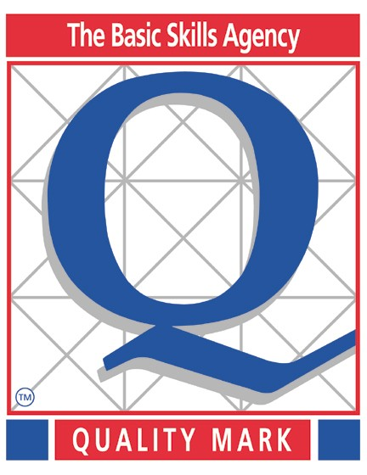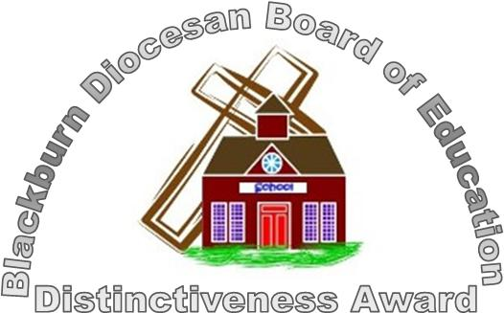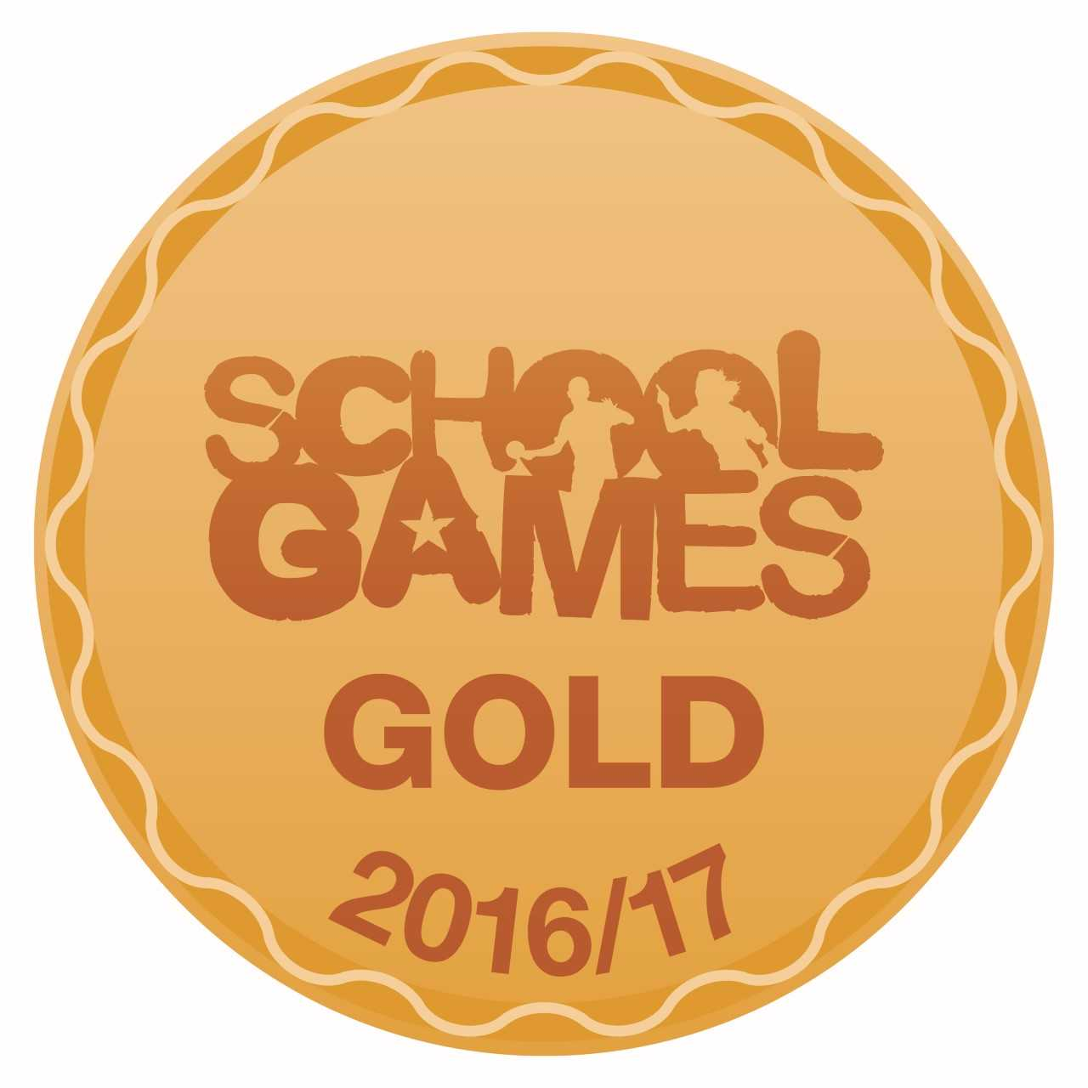

Headteacher : Mrs Alison Moxham Chair of Governors : Mr T. G. Wilson www.brethertonschool.org.uk

