
BRETHERTON ENDOWED CE
PRIMARY SCHOOL
South Road
Bretherton
Lancashire
PR26 9AH
Tel/Fax (01772) 600431
Email: head@bretherton.lancs.sch.uk

“Learning together, growing together, achieving together, caring together
within our Christian family”

So as I think about these children,
I give a smile, I laugh and I care
Never a quiet or dull moment indeed
They carry their own style and flair

From world war 1 and people who inspire
They’ve listened and learned and debated
Loving science and arts and all in between
They are 10 out of 10 star rated.

Thank you Tom for all you’ve done
In reducing the speed near school
an engineer and woodworker, and a great presenter too
You’re a bundle of fun, so cool.

A fine sportsman in Benjy, he’s really top class
Mountain biking and cricket, solo or in a team
Maths puzzles never phased him, and grammar too
A finer young man, has there rarely been

Captain Underpants is our Toby, he’s such great fun
Life and soul of the party he is
Always smiling and happy, a love of cats he has shared
Stories including them each time, he’s a whizz

A passion for science and finding out why,
Our Harry is top of the bunch
He’s sensitive and kind, a really nice guy
But he’ll always race you to lunch

Over the year Mia, you’ve grown your wings
And a lovely young lady you’ve become
So helpful and wise , almost beyond your years
But most of all so full of fun!

Tobias is our quiet and sensitive young man
Who loves animals through and through
He’s made strong friendships, both with girls and boys
Hanging out with him, you’ll never be blue
Jessica came back to join us last year
And for that we’re thankful each and every day
A talented gymnast and all round athlete
She’s all Gold and even a violin she can play.

Sophie another new girl in our family
We’ve loved getting to know her too
Kind and thoughtful and such a lovely friend
She’s Bretherton’s values through and through

Well Jack has a head for business,an entrepreneur
Who has great designs, ideas and a vision
From a love of dyson and all enginnering
how to make a million will be a difficult decision

We’ve been surprised to find the actor in Kyle,
Old codger, bishop, infact knowing everyone’s script
But a comedy connection we saw in our talent show
At Bishops he’ll be equipped

Our Hunky and sophisticated boy is great,
Adam is how you’ll know him well
He’s a talented beatboxer, just boxer and gamer you see
To us he’s thoughtful, caring, just swell.

Charlie is quiet and caring, a friend to all who he meets,
And his soothsayer is now very well known
But a runner, an athlete and natural sports leader
His talents are all homegrown
Well Archie’s talents are well known and second to none
From the lancs hotpots,1970’s, on ukele and brass
Quietly confident, with potential, his autograph I would like
For to us he’s always first class

Thank you for joining us, so we could share your last year
Matthew, your manners are second to none.
A quietly confident and talented sportsman,
In athletics or cross country never outrun.

Arianna is our sweety, our darling our love
An super actress who learnt her lines for the play
She is confident, caring and thoroughly good fun
She’ll be successful whatever her way.

Jacob’s general knowledge is abound with lots of facts
And he’s happy sharing them with all of the class
With his good ideas and maths puzzle brain
His high school friends he’s bound to outclass.

So to William, our reader, his head is deep in a book
a Harry potter expert, he knows and each one has read
he can play with all ages and all games, such is his fun
although equally happy in lessons instead.

So looking back on this year and how far you have come
I have seen you grown and mature and have fun
Always curious, and interested and willing to learn
A bright future is certain, our work here is done

As you move on to new pastures, different high schools await
You have learned through growth mindset, nothing is given on a plate.
Everything that’s worth doing , is worth giving 100% to
Be confident and happy and to yourself be true.

Whether with us since reception or only a year
We’ll miss you very much, we may shed a tear
Keep Bretherton close, locked in your heart forever
Remember who you are, and forget us never.

So with no further ado, I pass on my good luck
Be determined accept challenge, and never give up
For the future is yours , I know you’ll be fine
As you’re your light will continue to shine.

Wishing you every happiness and success in the world – You are always welcome and will be forever a part of Bretherton Endowed CE Primary School.

Mrs Alison Moxham

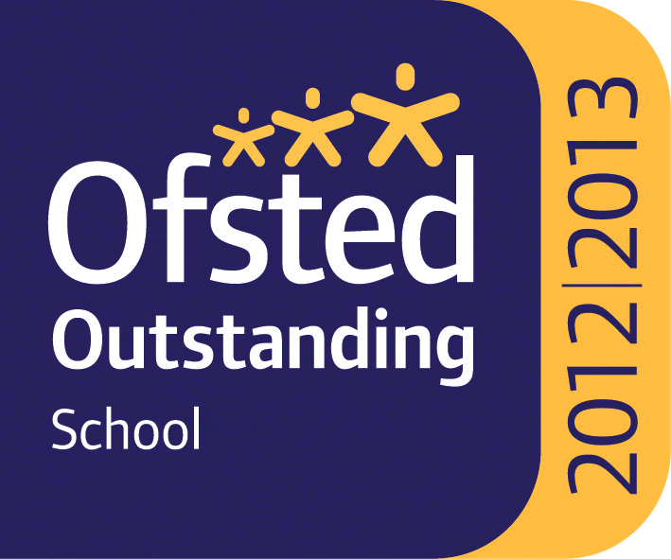

Headteacher : Mrs Alison Moxham Chair of Governors : Mr T. G. Wilson www.brethertonschool.org.uk

