The paper for Londoners 4th September, 1939
London Daily News
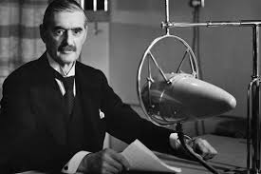
Britain and Germany at war

At 11.15am yesterday morning the Prime Minister, Neville Chamberlain announced that a state of war exists between Britain and Germany following Germany’s invasion of Poland.
In the last few months, Mr Chamberlain has valiantly tried to maintain the peace in the face of Hitler’s aggression. However, the unprovoked invasion of Poland has finally forced Britain to take military action.
Speaking on the radio, the Prime Minister explained that the German government had been ordered to withdraw their troops from Poland. He went on to explain, “No such undertaking has been received and consequently, this country is at war with Germany.”
Air-raid warnings
The city is now braced for German air attacks in the coming days. The evacuation of small children has already begun and everyone is reminded to listen out for air-raid sirens and carry their gas masks at all times.
The King’s message
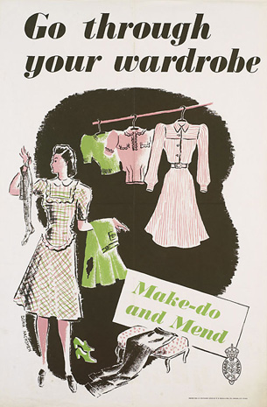
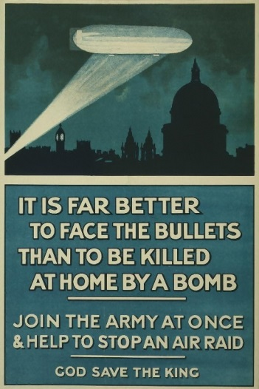
King George reacted to the news with calm determination, giving these words of encouragement, “There may be dark days ahead, but with God’s help we shall prevail.”
France joined Britain at 5pm yesterday and other countries are expected to make announcements in the coming days.

