The paper for xxxxxxxxxxxx 4th September, 1939
Daily News
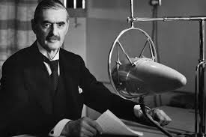
Title xxxx

xxxxxxxxxxxxxxxxxxxxxxxxxxxxxxxxxxxxxxxxxxxxxxxxxxxxxxxxxxxxxxxx

Write in paragraphs

Write with sub headings

Quotes from people who were there – use speech marks
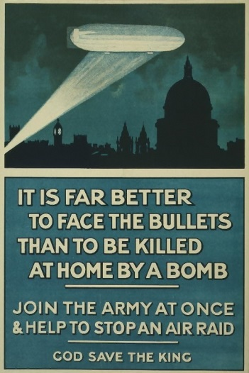
Title
xxxxxxxxxxxxxxxxxxxxxxxxxxx.
Title
Xxxxxxxxxxxxxxxxxxxxxx

What photos will you choose??

Include captions of photos

Write in columns

How will you end it??

