V1 Bomb in Lewisham High Street
- 28 July 1944
The V1, or Doodlebug, attacks on London began in June 1944 and lasted until March 1945. In all the London Boroughs Wandsworth took the most hits by V1s followed by Croydon. Lewisham was 3rd with 114 V1 rockets killing 126.
In Lewisham a V-1 rocket exploded in front of the clock tower in Lewisham High Street at 9:41am on Friday 28th July 1944 in the middle of a bustling market. The market stalls lined up outside Mark's and Spencer's, Woolworth's and Sainsbury's caught the full force of the blast, which came without warning.
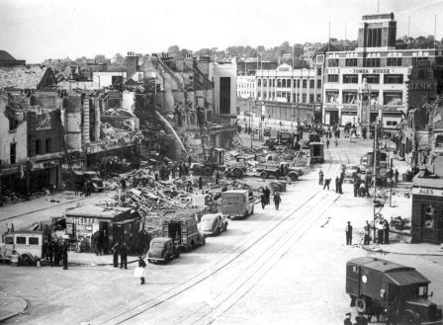
The bomb detonated on the roof of a surface shelter, which collapsed. Shops were demolished on both sides of the street. Casualties occurred in the basement cafe of Woolworths and even on passing buses. This bomb appears to be extremely strong, damaging property for 600yds. As the injured were treated, the more seriously injured were taken to the nearby Lewisham Hospital, which itself had been hit days before with 70 injured and 3 killed.
This was one of the worst V1 incidents in London with 52 dead and 216 injured. 100 shops had been badly damaged and the result was after the war this area of the high street was totally rebuilt on both sides.
(From http://lewishamwarmemorials.wikidot.com/)
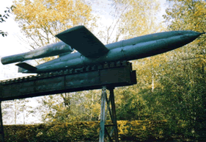
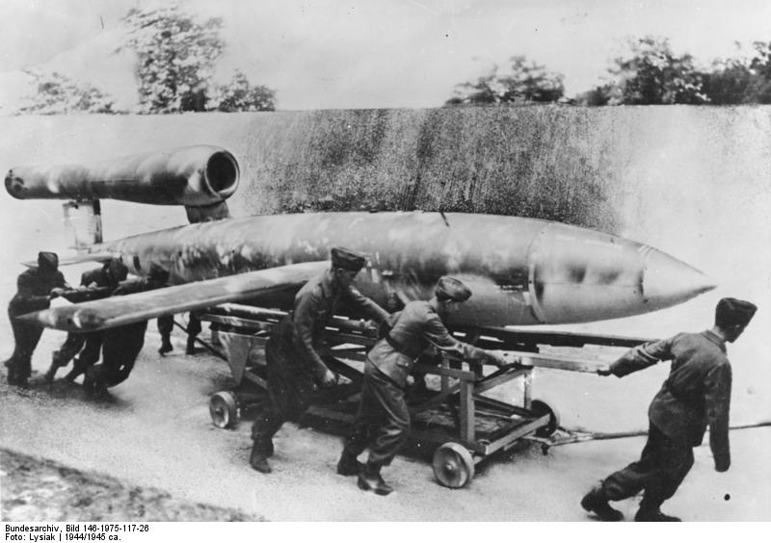
V1 Flying Bomb
– the ‘Doodlebug’
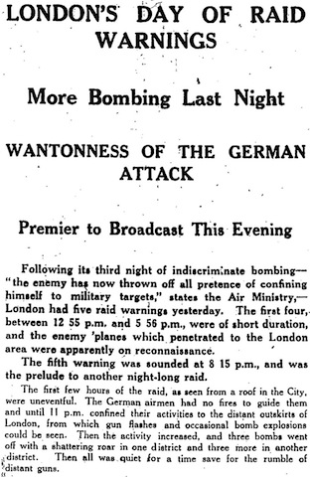
Extract from The Manchester Guardian – 10th September, 1940
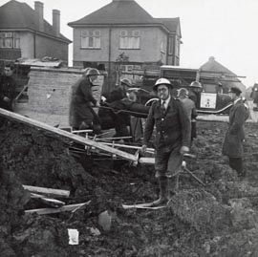
ARP Heavy Rescue Officer, Arthur Locke, works to clear the rubble and rescue people trapped inside buildings.

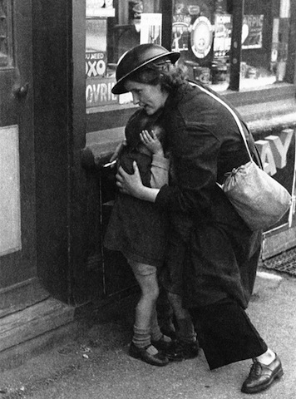
ARP Warden, Mary Crouchman, dives to protect a child from the bomb blast.
Lewisham schoolboy, Alf Morris, clutches his teddy in the debris.
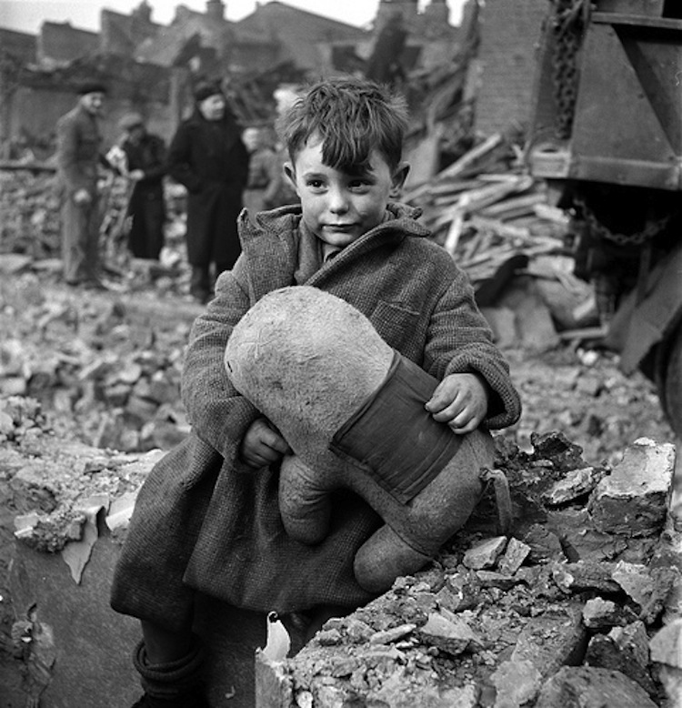
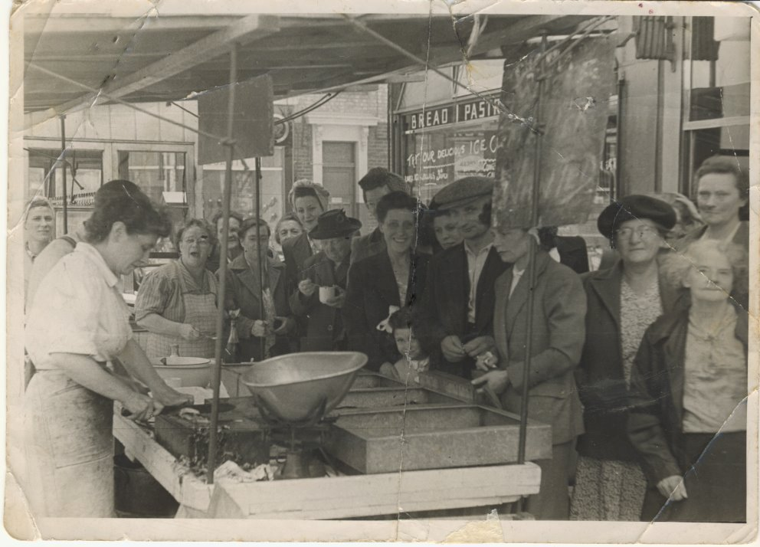
The market was full of people queuing with their ration books to get food and supplies.

Many people were on busses, travelling to work in the factories that made munitions.
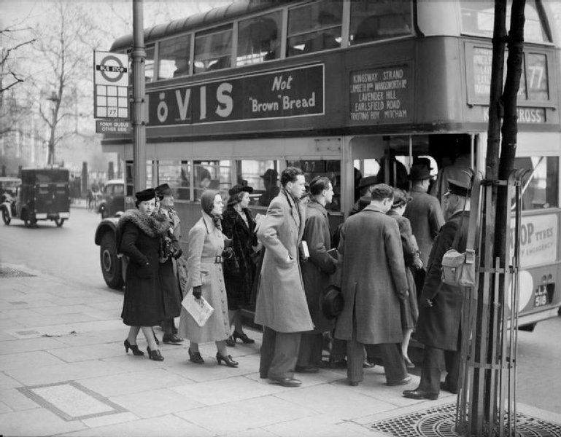

Despite the destruction, milkman Ernie Crouch still tried to do his job and get the milk delivered.
