Frank relives deadly visit of the Luftwaffe
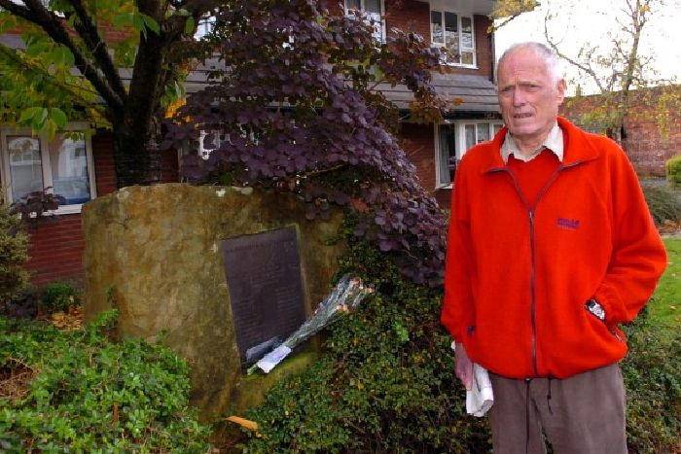
Frank Peacock, by the memorial on Ward Street in Lostock Hall

When a young Frank Peacock saw a German bomber flying overhead he dashed into the air raid shelter just seconds before an almighty crash.
Emerging into the evening light, the terrified nine-year-old realised his home, in Wateringpool Lane, Lostock Hall, had escaped bombing...but his relatives nearby had not.
It is now 70 years since the tragedy but Frank, 79, can visibly remember the moment his uncle returned from nearby Ward Street, with the news the home had been destroyed.
The entire Watson family, Frank’s aunt and uncle as well as six cousins, were killed when one of three bombs dropped on the street, hit their home.
Frank, a grandad-of-four and great grandad-of-one, said: “It was about tea time, five or six o’ clock and I was playing outside when I saw this aircraft overhead.
“My friend said it was German so we ran into the house.
“I thought he was kidding but a couple of minutes later we heard a big bang.
“We ran into the air raid shelter in the garden.”
Frank’s uncle Barry went to check on the family in Ward Street and returned with devastating news.
He said: “After a while he came back and said the house is down to the ground.I remember my grandmother being absolutely distraught and full of grief.
“Later my father and grandfather went down to try and dig them out.”
The family was among 25 people killed on 27 October 1940 when a bomb was dropped on the street.
It is thought Leyland Motors, vital for wartime munitions production, was the intended target, while some bombs in the region were dropped by planes unloading after raids in Liverpool.
Frank and his wife Margaret, 69, who now live in Fir Trees Avenue, Lostock Hall, visited the family’s grave in Leyland Parish Church on Wednesday, as well as a memorial in Ward Street.
He said: “This one, 70 years, was a big anniversary and the funny thing was, it was just after the Battle of Britain and they had stopped bombing Britain, it was just a one off.
“The tale was the pilot had been an apprentice at Leyland Motors.”
In the aftermath of the disaster neighbours in Lostock Hall clubbed together to make sure the 25 victims were not forgotten.
He said: “The whole family was wiped out.
“One thing about it was after we had collected for a memorial in the village, some money went to buy instruments for the Lostock Hall Memorial Brass band.
“They are still there and when I hear them play I think about it.
“I think it is a worthwhile thing to have done.”
A total of three bombs were dropped in the Ward Street area and other parts of Lostock Hall were also hit including the Pleasant Retreat Inn, where a memorial was erected.

