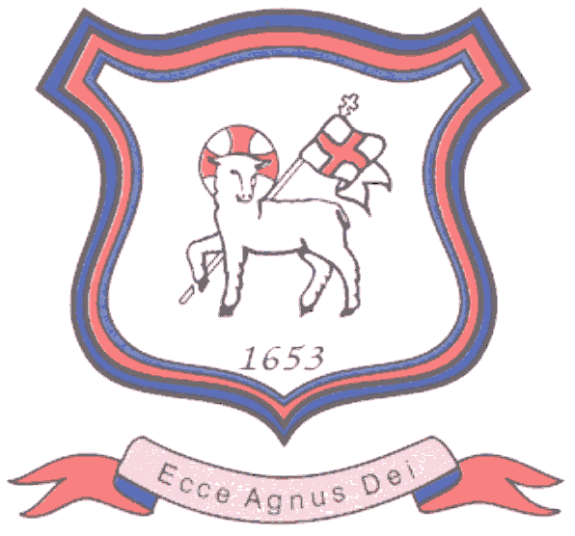
BRETHERTON ENDOWED CE
PRIMARY SCHOOL
South Road
Bretherton
Lancashire
PR26 9AH
Tel/Fax (01772) 600431
Email: head@bretherton.lancs.sch.uk

“Learning together, growing together, achieving together, caring together
within our Christian family”

Coronavirus distance learning at Bretherton
Dear Parents,
The staff and I have met to plan for some Online Learning and Home Learning ideas if school has an unavoidable closure.

Class 1 –
Go to Oxford Owl free online books
https://www.oxfordowl.co.uk/for-home/find-a-book/library-page/
Oxford Owl free Maths:
https://www.oxfordowl.co.uk/welcome-back/for-home/reading-owl/maths
ICT games ( add web link)
Discovery /Espresso
Purple Mash- school login ( add web link)
Phonics play website free section: https://www.phonicsplay.co.uk/
BBC Supermovers https://www.bbc.co.uk/teach/supermovers
Bake together as lots of Maths and language are used in this activity.
The following free apps: ReadwithPhonics.com
Chatterkid – photos and voice over

Class 2 -
Go to Oxford Owl free online books
https://www.oxfordowl.co.uk/for-home/find-a-book/library-page/
Oxford Owl free Maths:
https://www.oxfordowl.co.uk/welcome-back/for-home/reading-owl/maths
Phonics play website free section: https://www.phonicsplay.co.uk/
BBC Supermovers https://www.bbc.co.uk/teach/supermovers
Bake together/ play board games
The following free apps are also good:
ReadwithPhonics.com
Chatterkid – photos and voice over
DKTimestables
Lightbothour

Write a diary - remember those capital letters and full stops!
Purple Mash - child needs their password https://www.purplemash.com/sch/bretherton

Class 3
Go on Oxford Owl free online books and read at your level
https://www.oxfordowl.co.uk/for-home/find-a-book/library-page/
BBC Supermovers https://www.bbc.co.uk/teach/supermovers
Spelling Frame- https://spellingframe.co.uk/
Spelling
TT Rockstars- Child needs their password https://play.ttrockstars.com/auth/school
Purple Mash - child needs their password. As above
The following free apps are also good:
DKTimestables
Lightbothour

Class 4
Sats revision workbook
Learning by Questions- your teacher will set English, Maths and Science work.
We will text you a code for the correct work for that day. https://www.lbq.org/Task
Spelling Frame- https://spellingframe.co.uk/
Spelling shed https://www.spellingshed.com/
TT Rockstars- Child needs their password https://play.ttrockstars.com/auth/school
Purple Mash - child needs their password. ( add web link)

Each class can upload work onto our website – children login needed. They can create a Wikipedia page, enter a chat room and create a scrap book on a subject of their choice.

You can email me on head@bretherton.lancs.sch.uk with work or messages.

We hope this helps should the situation arise. We will keep everyone up to date as and when we have any further information.

Mrs A Moxham
Head teacher

