
BRETHERTON ENDOWED CE
PRIMARY SCHOOL
South Road
Bretherton
Lancashire
PR26 9AH
Tel/Fax (01772) 600431
Email: head@bretherton.lancs.sch.uk

Walking in the footsteps of Jesus with our Christian family, we learn, grow, achieve and flourish together in God’s love.

Meet the Teacher
Dear parent,

It is one of the key dates in our calendar that we hold our ‘Meet the Teacher’ session early into the new school year. Typically, this would provide an opportunity for your child’s teacher to outline their routines such as homework days, PE sessions, key learning and the age related expectations for that year so you can support at home. It also allowed time for you to discuss with the class teacher any concerns you have or any needs your child may have in relation to their education or friendships. Your child’s teacher was on hand for any questions or celebrations that you may wish to share.

At the moment, we are unable to offer our usual open door approach for your child’s teacher, so this year this session has become all the more important. Although it won’t be in same format, this year, our teachers will be available on the playground (except Mrs Williams, Class 1, who will be available near the hall doors) for a conversation should you wish to have one. If you feel you would like a longer conversation or would like to discuss an issue in confidence, please contact the school office to arrange a telephone consultation.

If you do not feel you have any questions or concerns, please do not feel the need to stay, as we will be holding our parent evening earlier this year. If you are unable to attend, please feel free to contact the office to arrange a call at a later date.

In this document, you will find the links to our website which contains the age related learning for the National Curriculum for all year groups for English and Maths. The class teachers have written welcome letters outlining their timetables and processes -these are attached and can also be found on their class pages on the website.

English and Maths Key Learning by year group can be found on http://www.brethertonschool.org.uk/page/end-of-year-expectations/34928

Learning in Early Years can be found on
http://www.brethertonschool.org.uk/page/eyfs---early-years-foundation-stage/57785

Recommended reading books for each year group http://www.brethertonschool.org.uk/page/english/34929

We are looking forward to a great year, despite current limitations and are delighted to be able to work with you for the benefit of your child’s education.

If we can be of any assistance, please do not hesitate to contact school. The relationship between home and school when strong, makes a huge difference to the outcomes for children. Working together we can ensure your children are the best they can be!

The Bretherton staff team

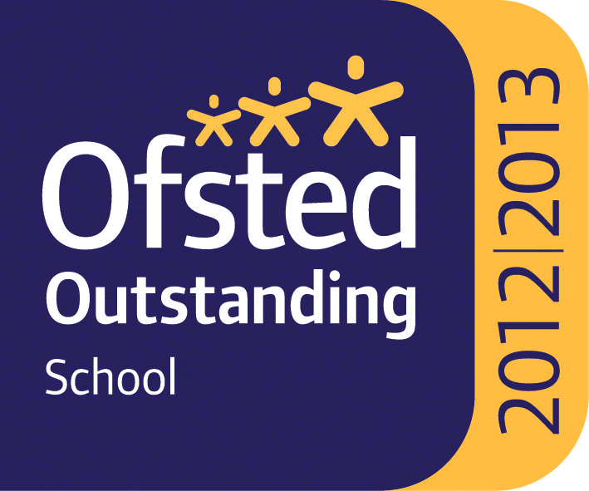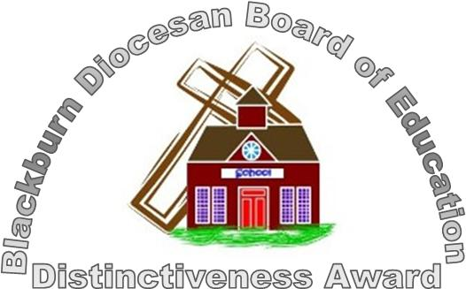

Headteacher : Mrs Alison Moxham Chair of Governors : Mr T. G. Wilson www.brethertonschool.org.uk

