
BRETHERTON ENDOWED CE
PRIMARY SCHOOL
South Road
Bretherton
Lancashire
PR26 9AH
Tel/Fax (01772) 600431
Email: head@bretherton.lancs.sch.uk

Walking in the footsteps of Jesus with our Christian family, we learn, grow, achieve and flourish together in God’s love.
28/ 9/20

Dear Parents,

We are really delighted to be back in school this term and although we were pleased that so many children and families found the learning at home strategy we applied through our website usable, we have had the time to reflect on how this could be improved upon should we be in this position again.

As part of the Government guidance, they outlined the need for schools to have a comprehensive plan for remote and /or blended learning available by the end of September. Remote learning means the facility to offer learning at home and blended the method of being able to teach the curriculum both in and out of school.

Although our website offered a great platform for home learning at that time, it was not designed for the amount of lessons we were uploading and over the summer, we have had the opportunity to reflect on what we need for the future.

So we would like to launch our Goggle for Education Platform and we plan to use Google Classroom as our home learning offer.

- Each child has a log in for google e.g. Joeblogs@bretherton.lancs.sch.uk
- Their password has been set and will require changing on first use. Please make a note of this at home.
- Their login although looks like an email, is actually only their login

Your child will be coming home with their login and password later this week.

Please could we ask you to log in with your child. WWW.google.co.uk (https://accounts.google.com/signin) and in top right hand corner it asks you to ‘Log On’

Please add the above log on and password and then change it to one you will remember for a mixture of letters/numbers/symbols for a minimum of 8 characters.

Once in if you click on the ‘Waffle’ (nine squares at the top - 1) at the top
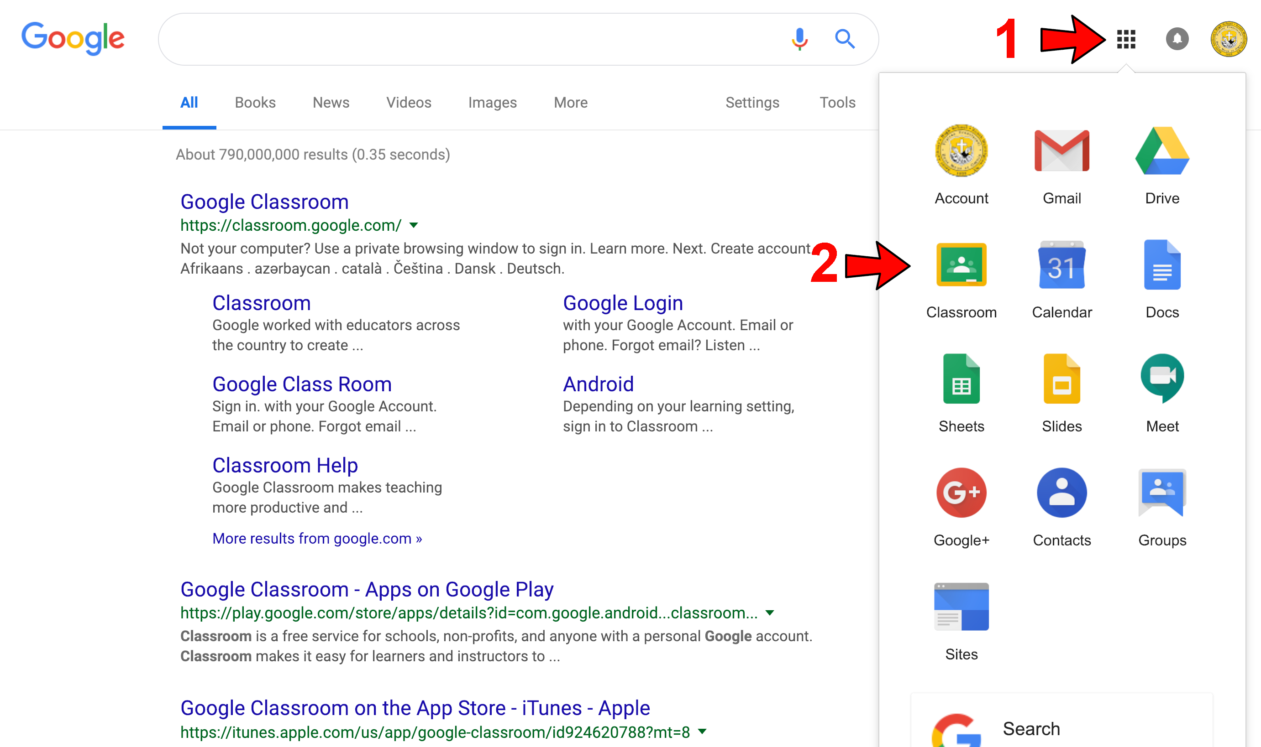

it will offer the google apps to use and the main area they will use if the Google classroom icon (2)

At the moment, our staff in KS2 are getting used to how to add lessons and give feedback by using it in class and our KS1 and Early Years staff will look at adding a few pieces of homework to ensure they feel confident to use when required. It will also give us some time to iron out any questions or concerns from parents or children.

We will create a ‘how to guide’ for parents so you can support your child using it, and this will follow later next week.

We have prepared a remote learning policy to outline what you can expect in the event of needing to learn at home. I have attached this for your information. To summarise, there will be two key reasons for work to be added to the platform:
1) An individual/ individuals being caused to self isolate for 14 days due to a family member being tested positive.
2) A class/bubble is asked to self isolate for 14 days due to a positive case.

This will be available from 1st October 2020.

If we ask a class/ bubble to go home for 14 days, we are aware of the demands on family this may cause and want to ensure that we do not add stress to households who are working, either at home or at work. We will be considerate of this in the timetable and work that is set. However, there will be an expectation that the work will be completed daily and submitted as per the request of the class teacher. We will be able to communicate with children through Google Classroom and through Google Meets. We will continue using Times Table Rock stars, Spelling Shed and Purple Mash as part of the provision.

We aim to offer at least Maths, English – reading and/or writing and Topic work daily with RE and PHSE weekly. We will also engage with children through remote worship.

We value our partnership with parents and are confident that we can get through any eventuality together. This is a new way of working for everyone so I would like to thank you in advance for your patience and understanding if there are any hiccups along the way. We are trying our best to factor in all eventualities.

Mrs Allchurch as IT lead will be leading this roll out and both of us will be available should you need any help with logging in or passwords.

Further information is to follow but if you have any questions in the short term, please let me know.
Kind regards,

Alison Moxham
Head Teacher

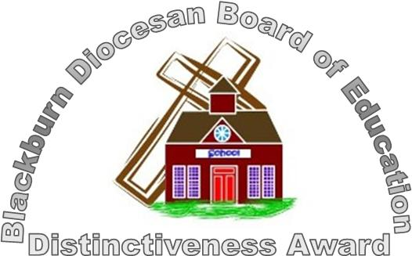

Headteacher: Mrs Alison Moxham Chair of Governors: Mr T. G. Wilson www.brethertonschool.org.uk

