

Walking in the footsteps of Jesus with our Christian family, we learn, grow, achieve and flourish together in God’s love.

Dear parents,

We hope that the increase in recorded lessons this week, enables your children to access the work more independently. These coupled with the meetings (Meets) with the teachers aims to help all children access their learning and succeed. We know our families are facing many challenges. Internet issues/connectivity have caused some challenges last week, as has sharing of devices but please contact us if we can help with either of these things.

We hope the contents of this letter may help save time and give a clear understanding of using Google Classroom at home.

If working on a laptop - Taking a photo of work done manually to upload.
1) If your technology (chromebook/laptop) has a camera, search in your computer 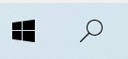 using the spy glass for ‘camera’ then hold the piece of work infront of it, click on take picture and it saves to your Pictures file within the ‘camera roll’. When you want to upload work, click on the + add from file and find in this file and attach.

2) Use the ‘How to’ sheet attached

3) You can download the google app that makes this easier on tablet.

You can do the same for video, for example, if they want to perform their English or share their skills for Golden time activities as videos.

Scheduled Learning

Our lessons match our curriculum but are adapted for home learning. I just wanted to explain that, like in school, lessons tend to follow on from each other so build on previous knowledge and skills each day. So accessing each day is helpful for the full sequence. The Google Meets can then be used for any questions or further teaching as required.
Each class will share a timetable of lessons for the week so that you know in advance where some lessons will happen, eg. PE on Tuesday, French Monday for some classes, Golden time Friday. This overview helps when we are in school so we hope it helps them at home.

Returning work

Children can return work or a photograph of the work by uploading it or just by making a comment and then clicking ‘Turned in’.
This is then highlighted for a teacher to review. This acts as a record of participation and helps feedback to the children directly.
For older children, the teacher may return the work with a comment and if there is anything extra that is required, they can resubmit. Mostly though, the teacher returning it with a comment will go back into the child’s Google Drive ( acts like an exercise book storing all previous work)

If possible, could we encourage children to uploaded any work to the correct assignment so that we can feedback and adapt planning for the next lessons. This will also help when we get back together to ascertain any possible gaps in understanding.

Feedback

We are providing feedback on learning as a whole class during our meets each day with areas for development and next steps as well as positive praise and motivation. Individual feedback may also be given to support the next day’s learning. In line with our feedback in school, different pieces of work will command different marking needs.
So feedback may be a grade to acknowledge work, private comment, voice comment or edited work returned. We know how important feedback is so teachers are encouraging children to start the day, looking at the feedback from the previous day’s work. Otherwise your child may miss seeing them.

Oak Academy

There are some brilliant lessons provided by Oak Academy and we will use them to complement our planning when they match our curriculum, but if you need any further sessions, please use them as they are age appropriate and mirror the year group expectations. The BBC are also offering great learning videos on BBC and Bitesize. Learning is learning in many forms.

Reading

Please remember from last lockdown that with a library card you can access E books. Also our website http://www.brethertonschool.org.uk/page/english/34929 lists the recommended books for each year group if that helps selecting books.

Also on Amazon kindle books, there are a selection of White Rose Maths booklets covering some aspects of maths that would help consolidate your child’s understanding. I believe Amazon are provising books for free each week for children through Kindle.

I am looking at how we can build more resources for reading into our home learning.

Golden Time
Thank you to children who have participated in our golden time challenges. New ones will be uploaded every Friday and the link will be available on their class stream. We had some lovely photographs and videos sent through.

Some other hints and tips people have shared with us:

- Google docs save automatically into drive so no need to save separately.
- To add a text box in Google drive or slides, you need to insert DRAWING and then the text box symbol can be seen.
- We will try and insert as many documents as we can in Google Docs rather than PDF. If we have to use PDF, we are still trialling different ways to add text boxes to make it is easy for your children. Should have this sorted on our network this week.
- Pressing control and d will mute and unmute you on Google Meet.
- If you are using a chromebook, we have been advised that if you click ALT and [ it allows them to split the screen so they can be on their meet and look at their work at the same time
- Children can have more than 1 tab open for reading and then completing their work.

Finally, although we are setting work on line through the platform, we understand that you can only do what is right for your family. This is not how we usually teach and we know children will be finding this level of screen time difficult for concentration. If they wish to draw, write in a book, act, perform their work, please just add a photo or video or they could turn in with a comment so that they receive the balance of education they would get at school. Hopefully the ease of uploading pictures will make this available.

Learning can happen in many ways. Please contact us if there is anything we can do to support your child.

Take care,

Alison Moxham
Head Teacher

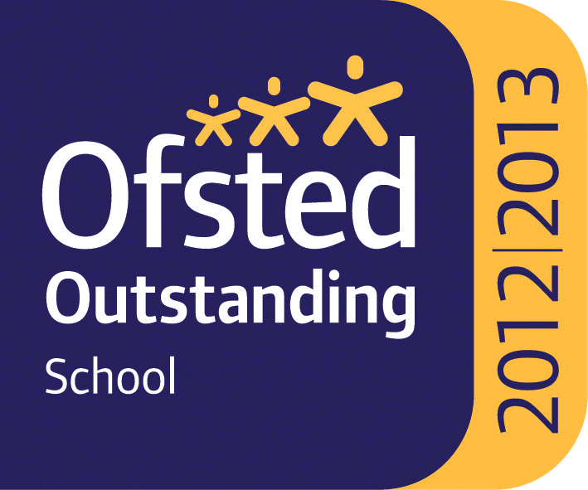

Headteacher : Mrs Alison Moxham Chair of Governors : Mr T. G. Wilson www.brethertonschool.org.uk

