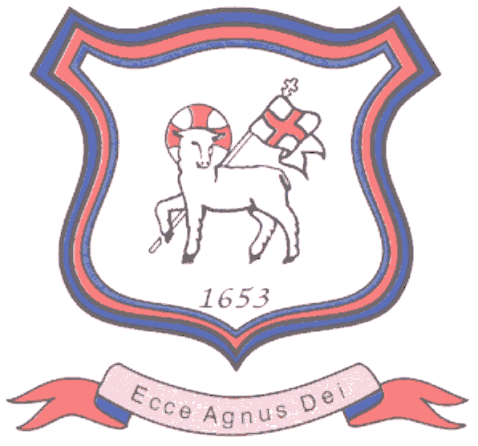
BRETHERTON ENDOWED CE
PRIMARY SCHOOL
South Road
Bretherton
Lancashire
PR26 9AH
Tel/Fax (01772) 600431
Email: head@bretherton.lancs.sch.uk

Walking in the footsteps of Jesus with our Christian family, we learn, grow, achieve and flourish together in God’s love.

Dear Parents of Year 6 children,

With only a week to go, we are writing to advise you of the timetable for SAT’s week. It is important for you to know what is happening each day and would ask for your support in ensuring that your child gets plenty of rest, and a good breakfast, leading up to and during this week.

All the children in Year 6 have shone in their attitude to learning, developing their understanding and ability to work hard and persevere, even when things get tricky. The children continue to work hard to prepare for this important week which gives them a chance to showcase the knowledge and skills they have learnt across the whole of Key Stage 2. Despite the pandemic, they have worked extremely hard this year and we know that they are prepared.

Above all, we want the children to feel confident and able to give their best during this week and not to feel any undue pressure. To use their positive attitude, to relax, stay calm and take this opportunity to ‘Shine’.

Children will need a rigid plastic water bottle (one that doesn’t make a noise when squeezed) if possible and is able to bring in a small item if they feel they need a ‘Good Luck’ charm.

Teaching your children has been a huge privilege this year and we would like to take this opportunity to thank you for your support in working with school in encouraging your child to complete homework and work on their targets at home. If you feel that you need any further information or you have any queries, please don’t hesitate to get in touch with us.

Kind Regards,

Bretherton Teaching Team

Timetable W/C 9th May 2022

Monday 9th May 2022 English Grammar, Punctuation and Spelling Paper1
Spelling Paper 2: Spelling

Tuesday 10th May 2022 English Reading

Wednesday 11th May 2022 Mathematics Paper 1:Arithmetic
Mathematics Paper 2: Reasoning

Thursday 12th May 2022 Mathematics Paper 3: Reasoning

In Year 6, all writing is assessed throughout the year and a judgement as to whether or not a child has achieved the expected standard will be given by the Year 6 teacher towards the end of the summer term.
In Science, your child will be recorded as working at the expected standard or not yet met expected standard based on our internal assessments.

Test Results
This is the first Statutory Assessments since 2019 due to the pandemic. This information has been written based on current guidance.

Pupils will get marks for correct answers and these will be converted into a scaled score with 100 representing the "national standard".

The interpretation of scaled scores is as follows:  Mark | Description
Less than 100 | Below Expected Standard
At 100 | At Expected Standard
Above 110 | Above Expected Standard (typically, although this can change)

You will receive test results for your child in English reading, English grammar, punctuation and spelling and mathematics. You will also receive separate teacher assessment judgements for English writing and science within your child’s end of school year report.

These results will be shared with your child’s chosen high school along with our teacher assessed grades.

